1. Open browser and search Okta developer
2. Login using google gmail.
3. Then you will get your domain information. That is your URL

<https://dev-82667125-admin.okta.com/admin/getting-started>

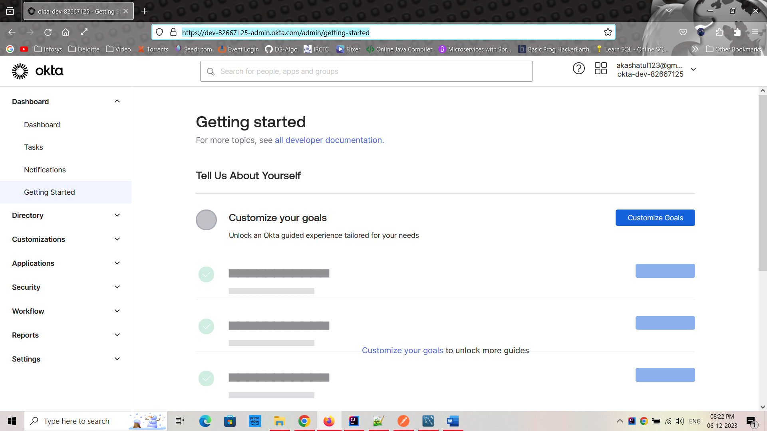

1. Go to “Application” from LHS

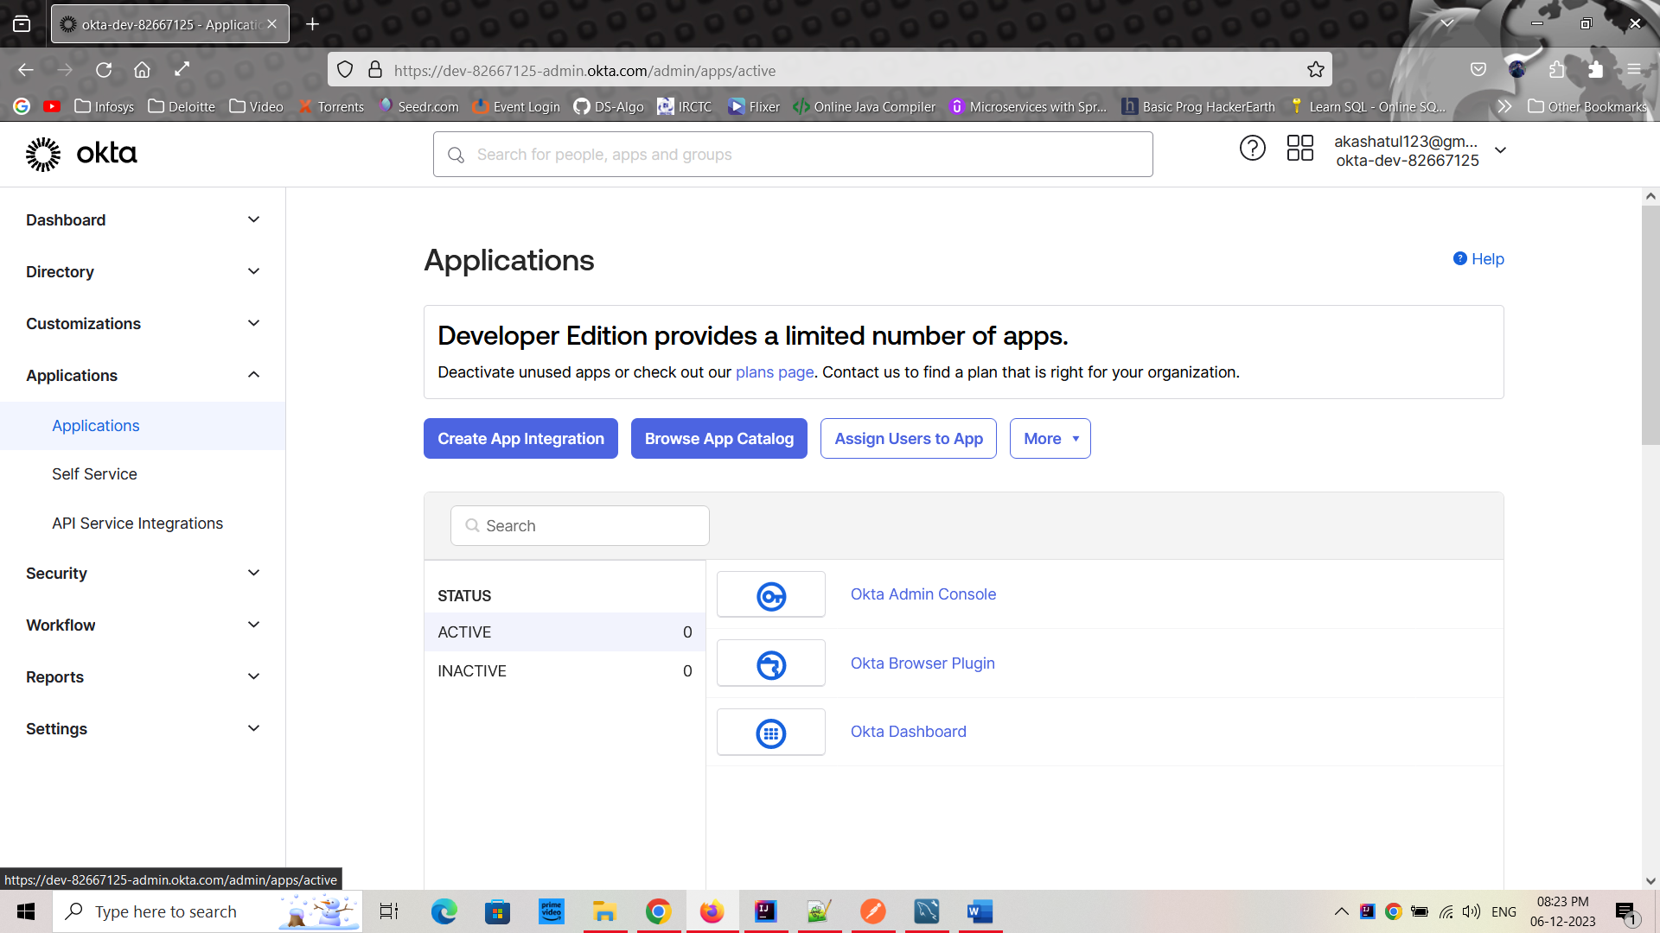

1. Click on “Create App Integration”

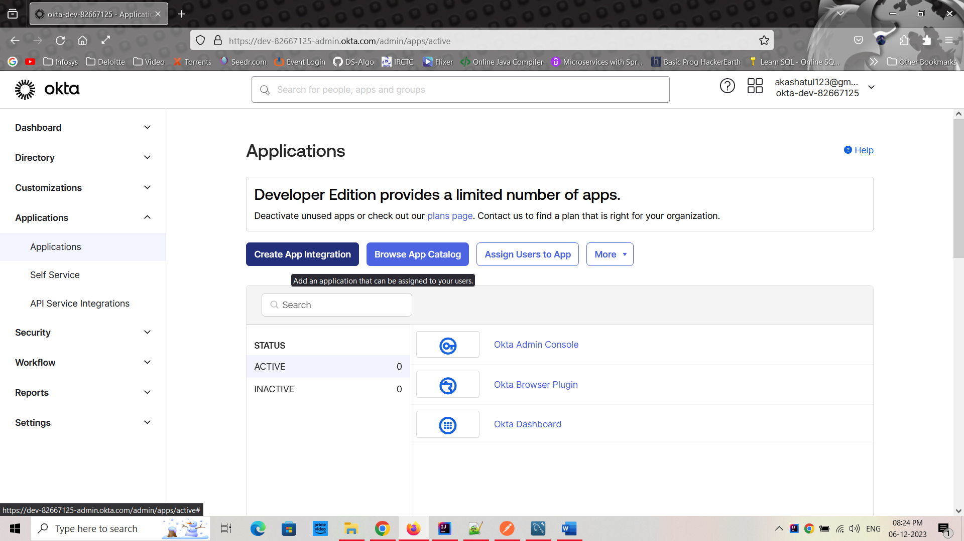

1. Select OIDC then Web Application Then Click on “Next”

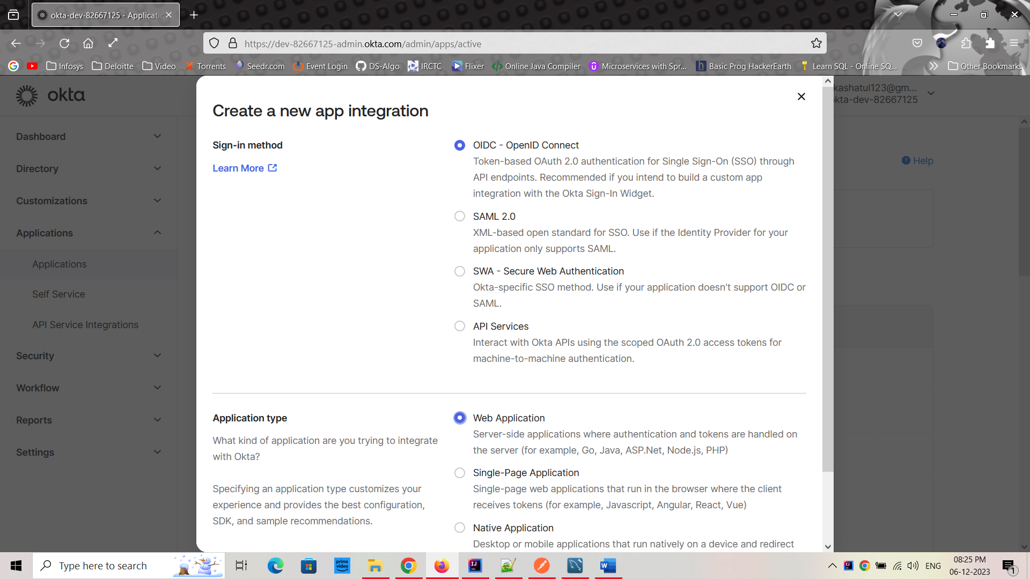

1. Give:- Name: microservices

GrantType: 1. Client credential

2. Refresh Token

Sign in URL: <http://localhost:9090/login/oauth2/code/okta>

Sign out URL: <http://localhost:9090>

Controlled access: skip group assignment for now

Then Click on “Save”.

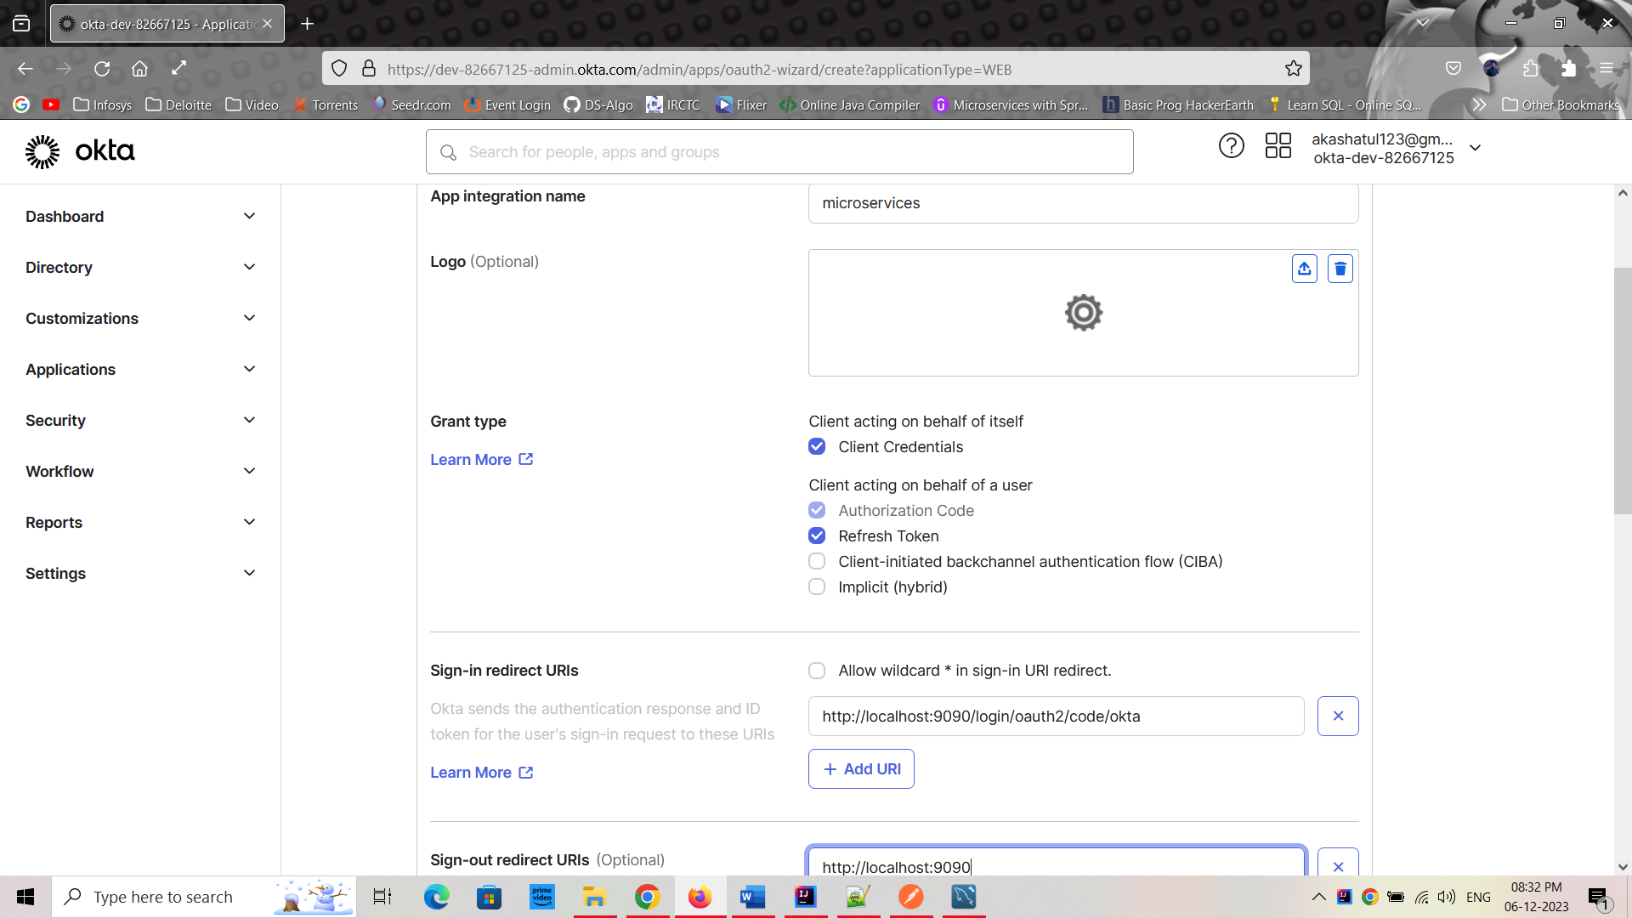

1. Now you will get the: (Do not share it with anyone)
   1. Client ID: 0oadomcujsM65TKGi5d7
   2. Client Secret:

-XhiAWlzl4vpaUfav1e5s_rqImAtF2c7AyL9gJ1YAELn_qCZ2JEibSX59QkSJr0e

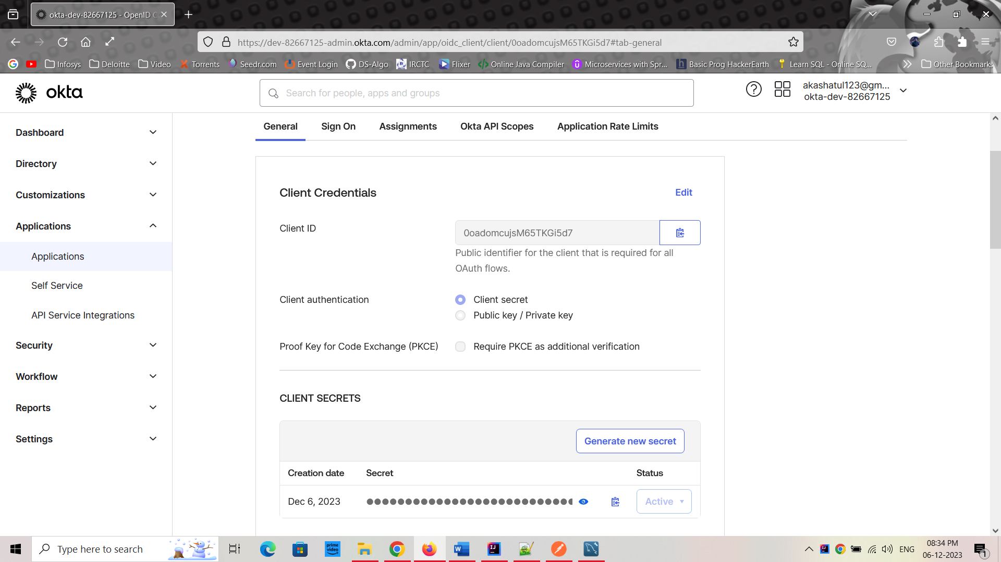

1. Once it is done, now Go to “Security->API” tab from LHS. Here we can see the Authorization Server. Then Click on “default”.

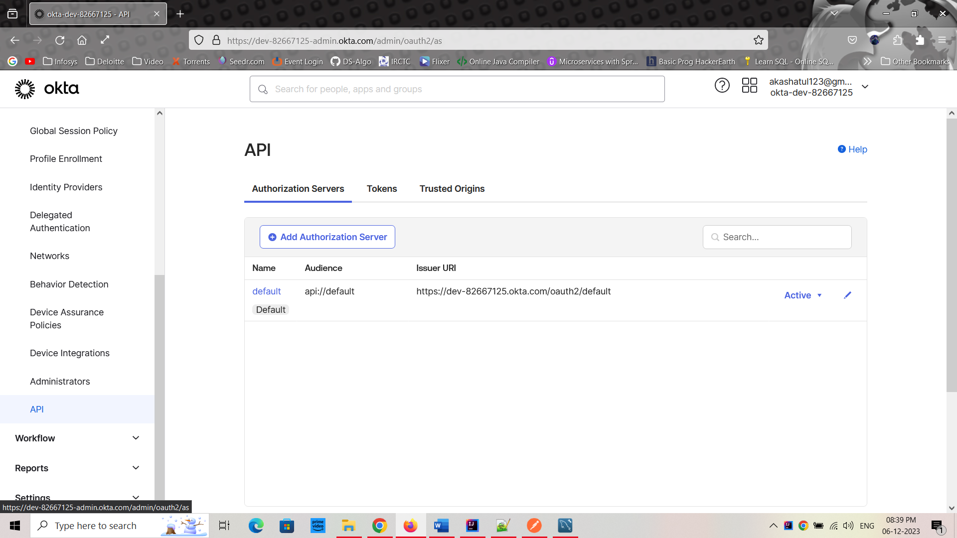

1. We come to “Scopes” tab. We want to define our own scope as “internal”. Because we want to communicate between internal services like ProductService to PaymentService.

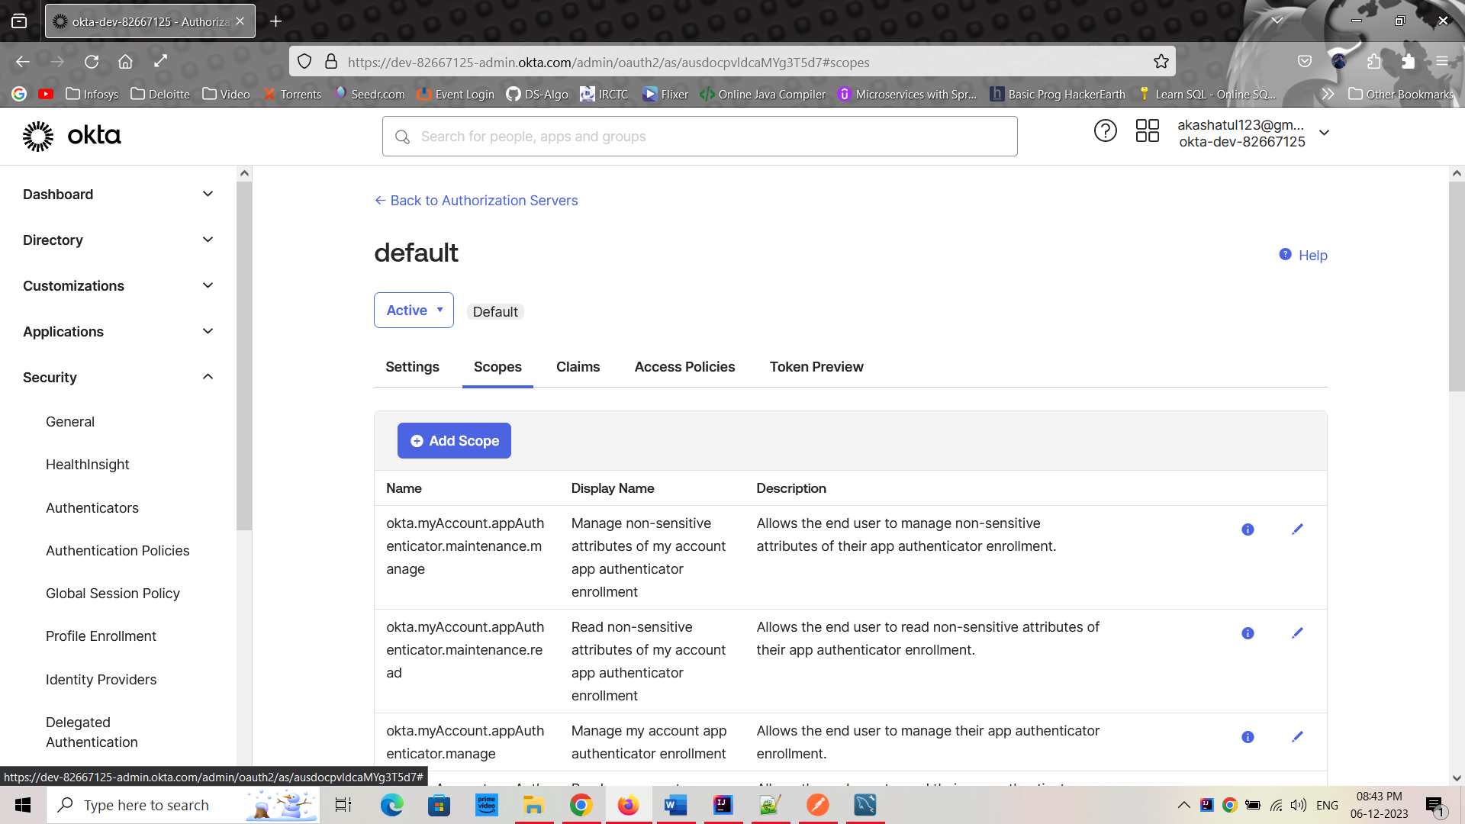

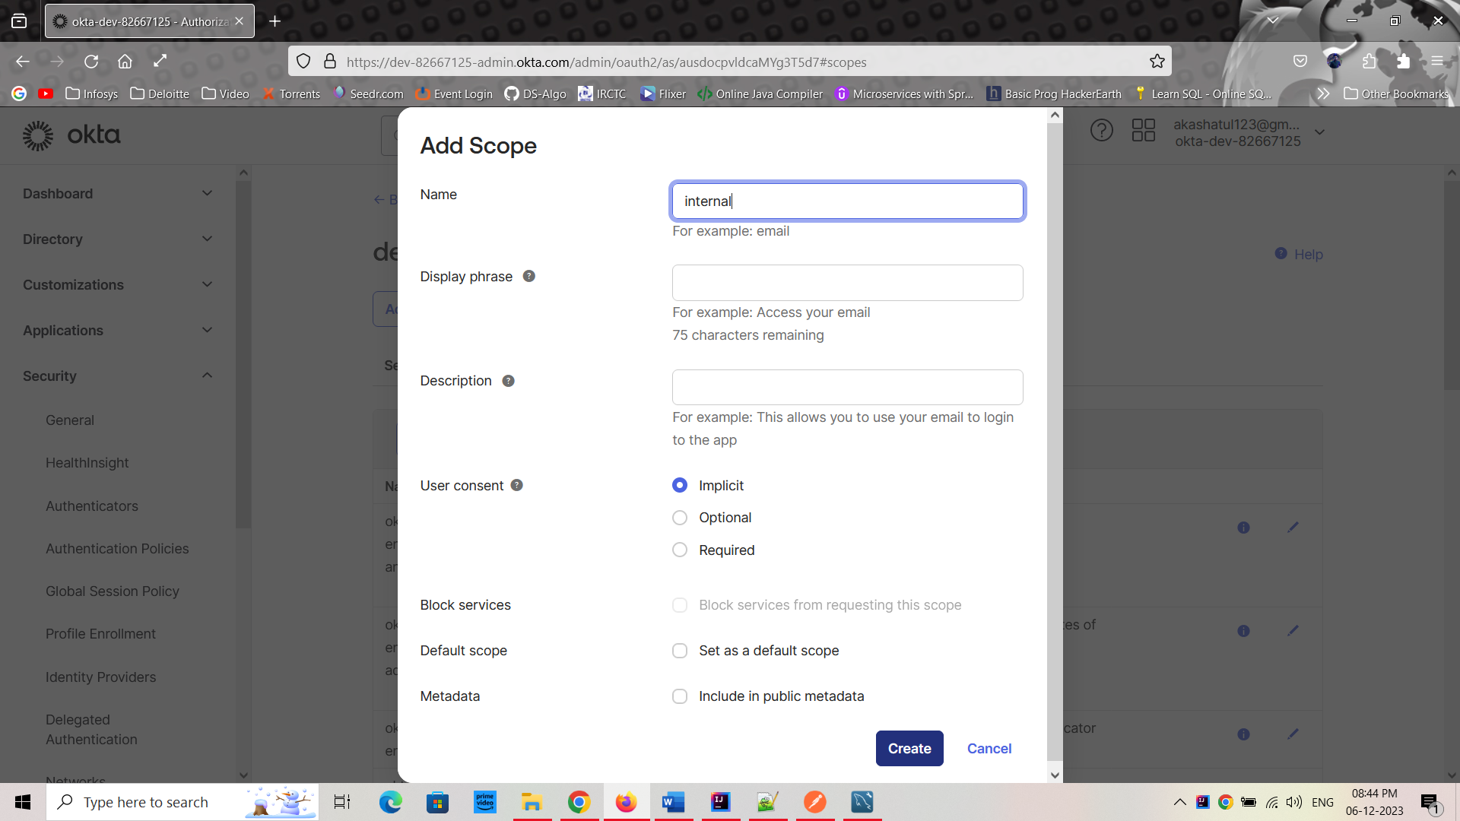

1. Click on “Create”. All the details as default we used here.

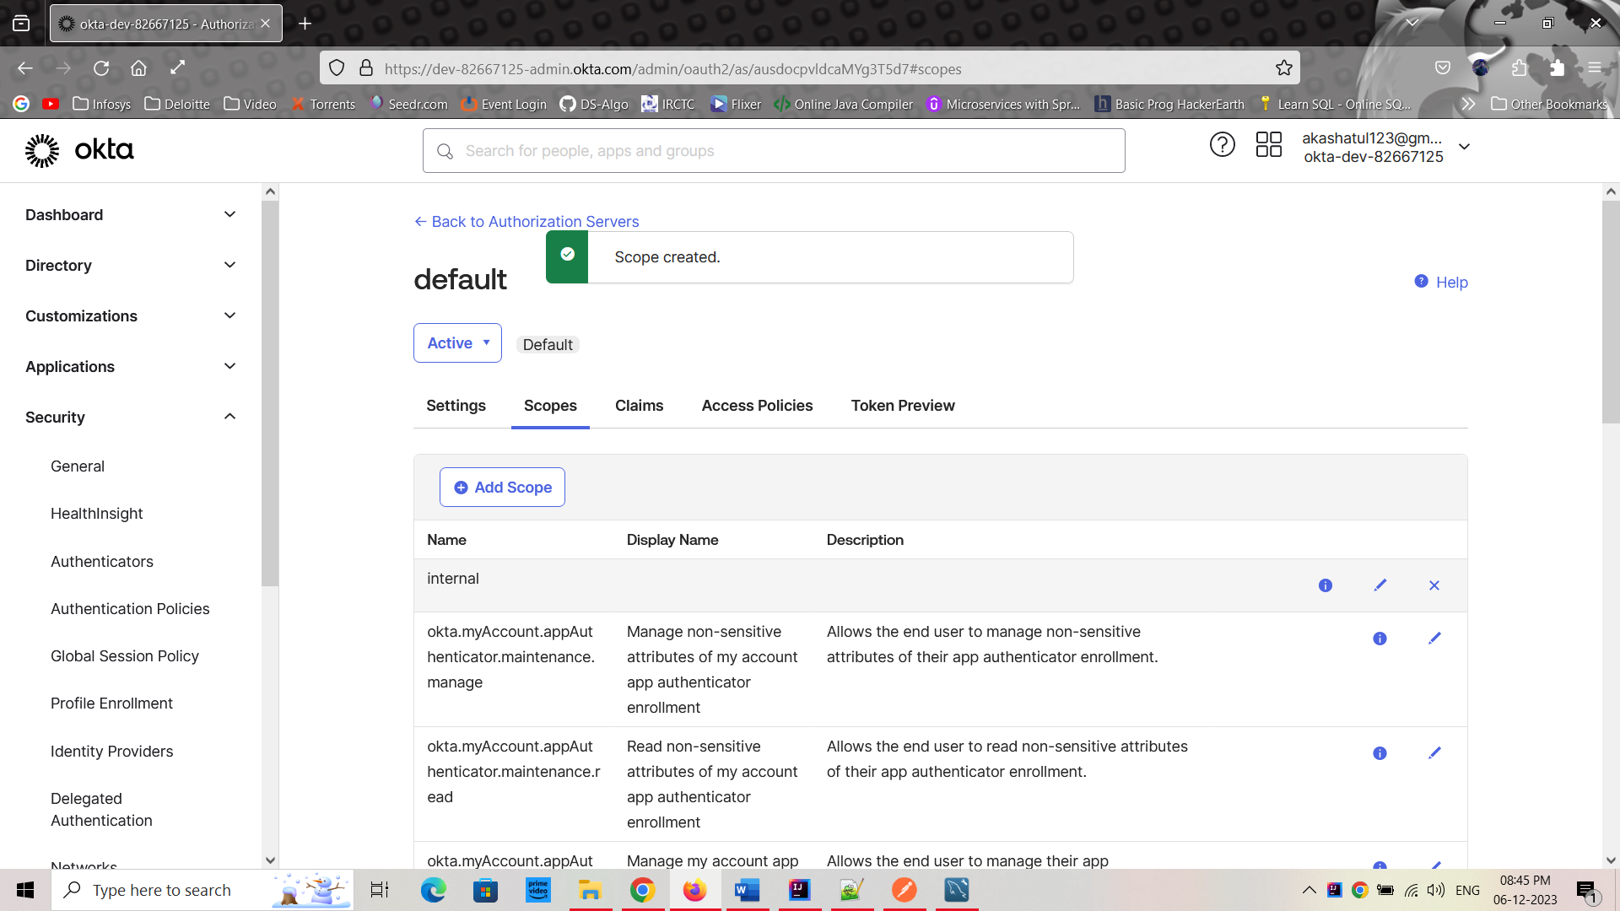

1. On the LHS, Go To “Directory-> groups” open groups on new tab

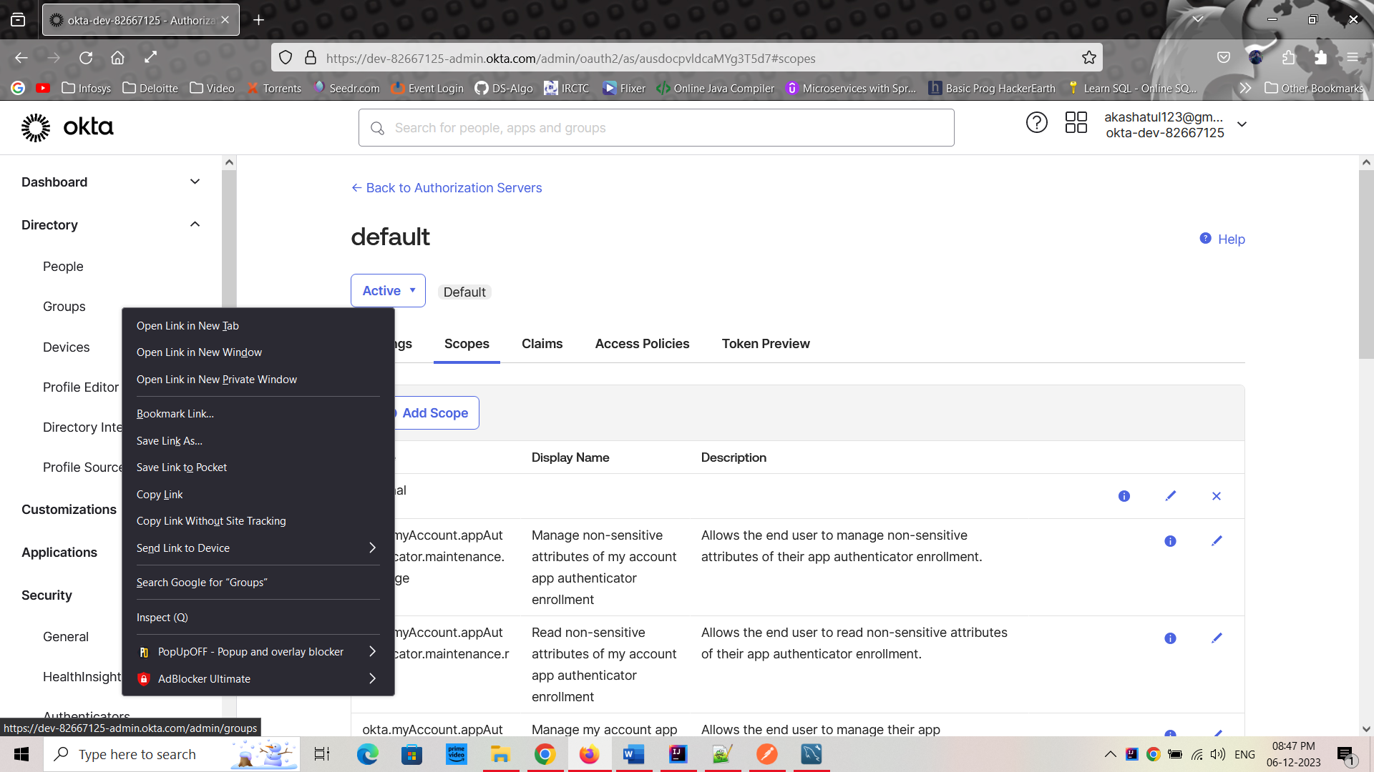

1. Create to new Groups:
   1. Admin
   2. Customer

Then close this tab and go back to the old tab.

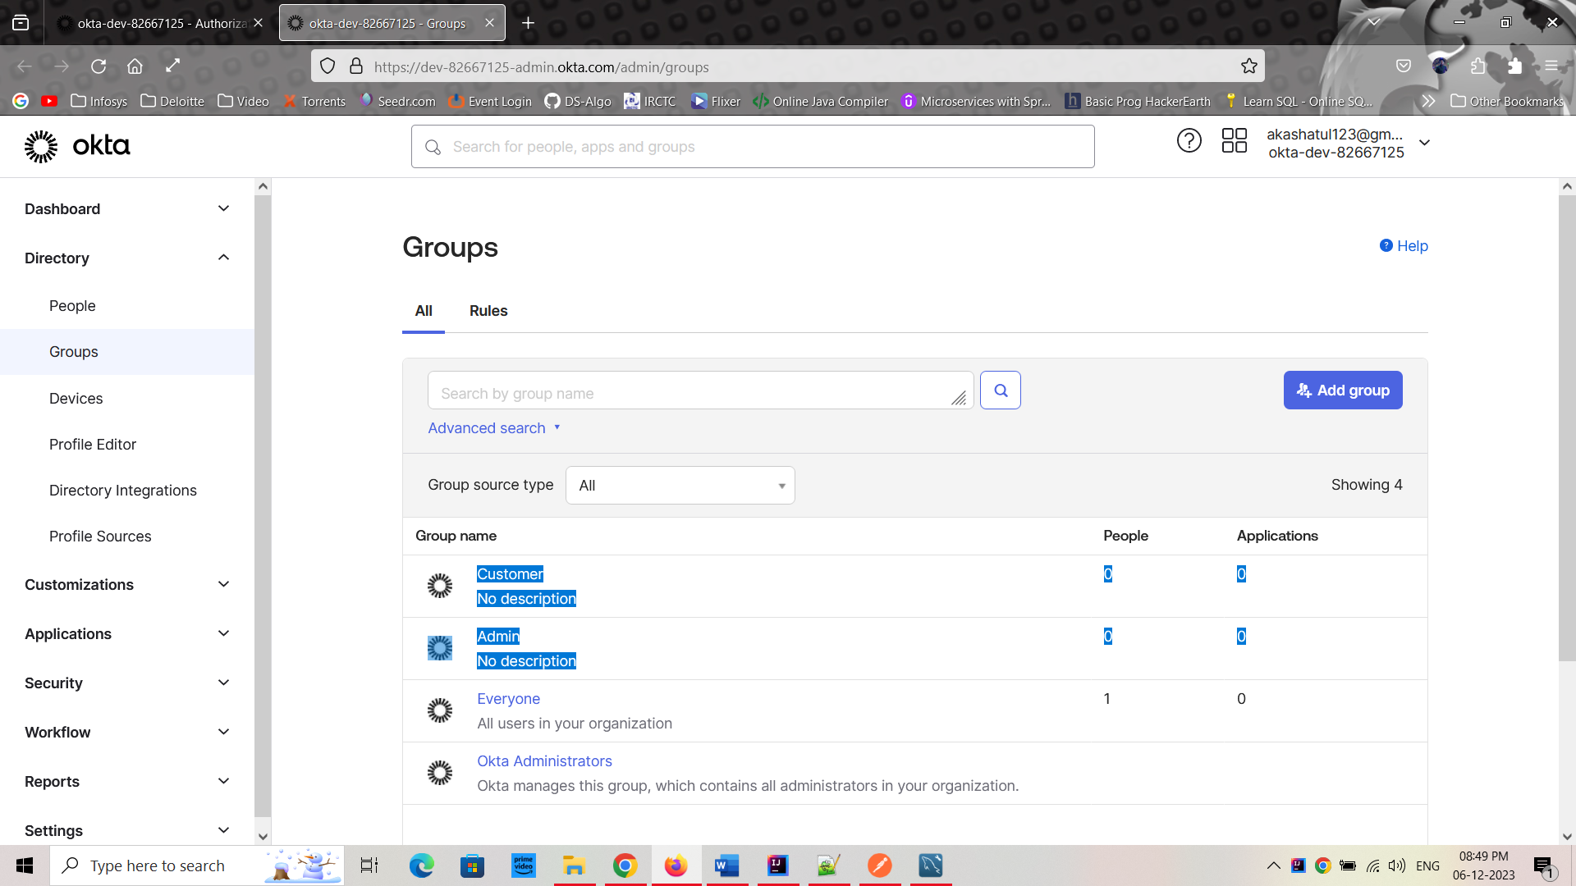

1. Go to “Claims” and Add new claim:
   1. Name: groups
   2. Value Type: Groups
   3. Filter: Matches regex= .*
   4. Click on Create

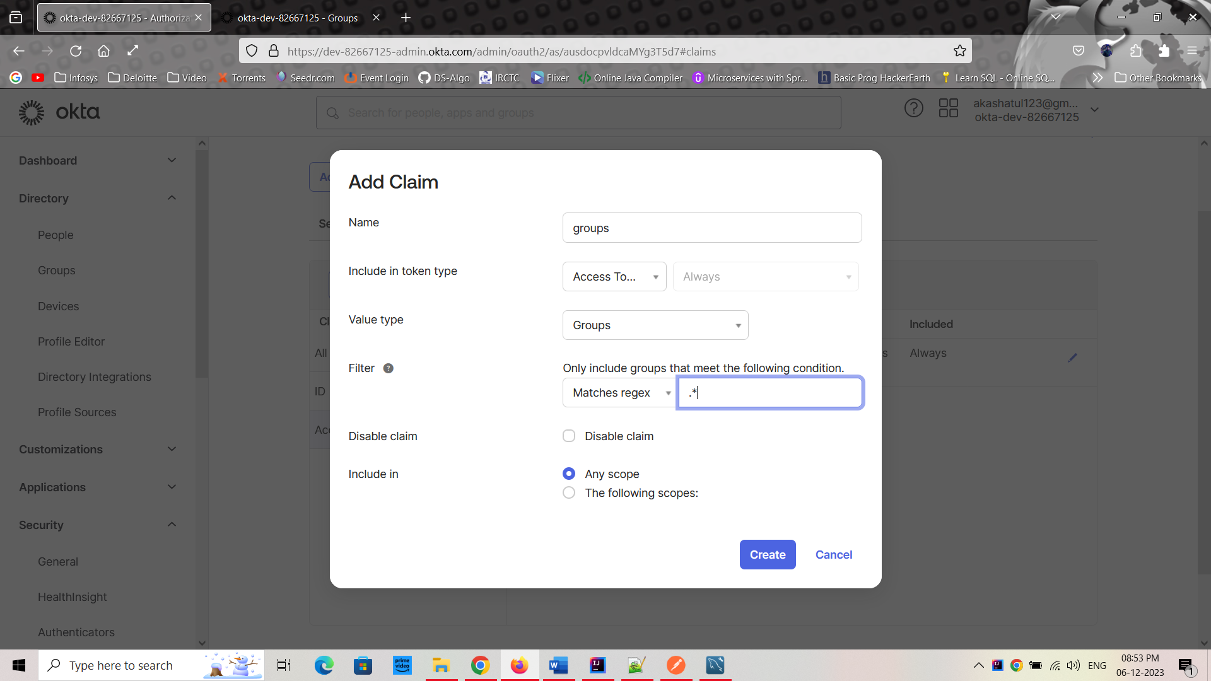

1. Now okta configuration is done.

